Press Release: [DATE]

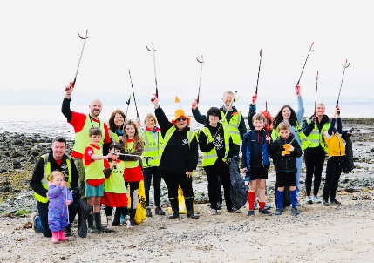
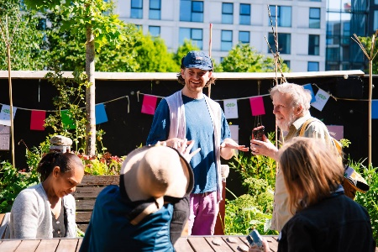
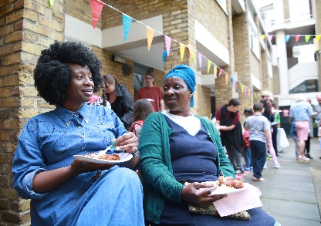

[ORGANISATION NAME] joins in with The Big Lunch and The Big Help Out for a weekend of community action on 5 – 8 June!

[Organisation Name] is delighted to be joining in with a big weekend of friendship, food, fun and action on 5-8 June. The Big Lunch, the annual celebration for neighbours and communities, is teaming up with with volunteering initiative The Big Help Out to encourage even more people to take action where they live this June – and everyone in [area] is invited!
It’s a chance to embrace community spirit in towns, cities and villages across the UK, with millions of people expected to come together to eat, meet and lend a hand locally, making a difference for people, place or planet as a result.
The new campaign, run by national charity the Eden Project, calls on people to get involved in whatever way works for them – whether that’s by organising a street party, getting the neighbours together for a litter pick or visiting a local charity to get involved for the day. From a bite to eat on the street to community-led volunteering opportunities and partnerships with charities and businesses, there’s something on offer for anyone keen to make a positive difference where they live.
Lindsey Brummitt, Eden Project Programme Director, said: “We couldn’t be more excited to be bringing The Big Lunch and The Big Help Out together this year for a weekend that’s sure to be absolutely overflowing with community spirit! There’s no better opportunity to get to know new people, support some amazing causes and try your hand at something a bit different. Whether you’re sharing food and fun or getting together to get things done, doing picnics or litter picks – everyone’s invited to do something! Find everything you need to get involved at thebigdo.com”
Running annually since 2009, The Big Lunch is the UK’s annual get together for neighbours and communities when millions of people come together to share friendship, food and fun on the first weekend in June. It is an idea from the Eden Project, made possible by the Pears Foundation and supported by Co-op.
The Big Help Out started in 2023, encouraging people to have a go at volunteering, lend a hand and make a difference. Millions of people took part in 2023 and again in 2024, as charities offered simple, light touch opportunities for people to find out more and see what volunteering was all about.
With so many positive benefits for people to enjoy, [organisation name] is taking special steps to make it easy for people to join in by:

[add or delete as appropriate]
- Sharing all the latest Big Lunch and Big Help Out news and support to help anyone planning events
- Holding taster events for people to learn more about their organisation
- Waiving street closure fees for any Big Lunch and Big Help Out events and making road closure applications easier with more time to apply [Add link]
- Offering up a limited number of Big Lunch and Big Help Out funding grants [Add link]
- Inviting residents to use local parks and green spaces to get together

Bringing The Big Help Out and The Big Lunch together is made possible by funding from the Pears Foundation, the UK Government and Co-op and the Eden Project are calling on everyone UK-wide to join in on the weekend of 5-8 June. This nationally significant moment will also form part of Volunteers’ Week and the Month of Community.
This year, The Big Lunch and The Big Help Out are teaming up from 5-8 June for one big do! And everyone in the UK is invited, so what will you do? Find out more at thebigdo.com
For [NAME OF ORGANISATION] media enquires contact [ADD DETAILS]

ENDS

About The Big Lunch
The Big Lunch is an idea from the Eden Project made possible by the support of Pears Foundation and corporate partner Co-op. It’s the UK’s annual celebration for neighbours and communities bringing millions of people together in a nationwide act of friendship on the first weekend in June every year since 2009. Her Majesty The Queen has been Patron of The Big Lunch since 2013.
For The Big Lunch follow us at @edencommunities: Instagram, Facebook, LinkedIn and for Eden Project news follow @edenprojectcornwall on Instagram, TikTok / @edenproject on X and LinkedIn.
To find out more about The Big Lunch go to www.TheBigLunch.com and for the Eden Project go to www.EdenProject.com.
About The Big Help Out
The Big Help Out started in 2023, encouraging people to have a go at volunteering, lend a hand and make a difference. Millions of people took part in 2023 and again in 2024, as charities offered simple, light touch opportunities for people to find out more and see what volunteering was all about.
Find out more at www.thebighelpout.org.uk

About Pears Foundation
Pears Foundation is an independent, British family foundation driven by a desire to demonstrate the good that philanthropy can achieve in the world. It is the philanthropic foundation of the Pears family, who have given more than £450million to charity since the Foundation was established. The foundation is focused on building long-term relationships with partners, providing core funding and offering more than money through organisational and leadership development programmes, with the aim of demonstrating the foundation’s vision of good philanthropy and the value of leading by example. To find out more, visit pearsfoundation.org.uk
About Co-op
Co-op Group is one of the world’s largest consumer co-operatives, with interests across food retail, funerals, insurance, and legal services. Co-op is owned by and run for its 6.2 million members. With over 2,300 food stores and more than 800 funeral homes, Co-op also supplies products to 6,000 other outlets, including those run by independent co-operatives, through its wholesale business, Nisa Retail Limited.
Employing 55,000 people, Co-op has an annual turnover of over £11 billion and is a recognised leader in social goals and community-led programmes. Co-op exists to meet members’ needs and champion the causes they believe in.

