Press Release: [DATE]

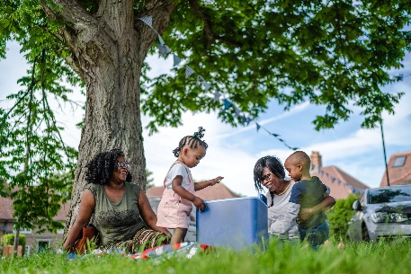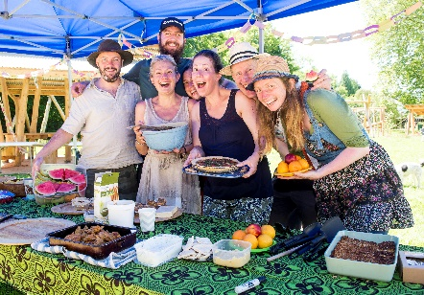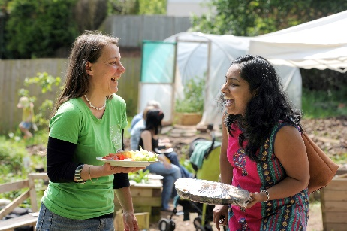

[COUNCIL NAME] ANNOUNCES THE BIG LUNCH IS BACK ON 1-2 JUNE 2024 AND IT’S SET TO BE THE GREENEST YET!

[Council Name] is delighted to announce that The Big Lunch is back in [area] on 1-2 June 2024. It’s a chance to join in a special moment when millions of people right across the UK will get together in their communities to share friendship, food and fun – everyone in [area] is invited!
The Big Lunch is a simple idea that can make a big difference. People are the key ingredient and we all have something to share, from food and conversation to music and laughter. It creates friendships, increases belonging and can help new neighbours feel welcome. It’s also a chance to celebrate the people who volunteer their time throughout the year to have a positive impact, and it’s a fantastic opportunity to fundraise for local causes.
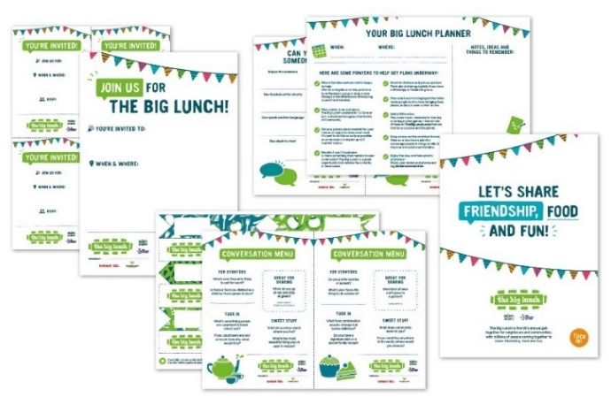
To help get the party started and make this year’s events the greenest yet, The Big Lunch is sharing free resources and tips from pocket and planet friendly recipes to share, upcycled decorations to make, street games to play, and ways to boost nature in your neighbourhood which are all available at TheBigLunch.com. You can also look out for exciting celebrity news, competitions and collaborations with a host of partners including WWF on The Big Lunch socials @edencommunities.

In 2023, supported by Her Majesty The Queen who has been patron since 2013, more than 14 million people took part in The Big Lunch. Eden Project’s impact research* shows that 65% of those who did say it made them feel less lonely, 67% feel safer in their neighbourhood, 75% said they feel a stronger sense of community spirit and the same number said they are more likely to give time to help neighbours or good causes. A similar number (76%) said joining in had helped them to feel they belong more to their community, and 80% said it made them feel like they were part of something which connected the country together. With so many positive benefits for people to enjoy, [council name] is taking special steps to make it easy for residents to join in by:

[add or delete as appropriate]
- Sharing all the latest Big Lunch news and support to help anyone planning events
- Waiving street closure fees for any Big Lunch events
- Making road closure applications easier with more time to apply [Add link]
- Offering up a limited number of Big Lunch funding grants [Add link]
- Inviting residents to use local parks and green spaces to get together

Lindsey Brummitt, Eden Project Programme Director responsible for The Big Lunch said: “Since 2010, we’ve been bringing people together to create happier and healthier communities thanks to National Lottery players, who raise £30 million each week for good causes right across the UK. The Big Lunch is all about sharing friendship, food and fun and this year we’re also sharing top tips to help make 2024 the greenest Big Lunch ever! With Big Lunches set to take place across the country, why not pick a date to get involved and spread the word so that [area] has more Big Lunches than ever with everyone having fun together! We’ve got everything you need to get the party started at TheBigLunch.com!
The Big Lunch is the UK’s annual community get-together that’s good for people and the planet, bringing friendship, food and fun back to neighbourhoods on 1-2 June! It’s an idea from the Eden Project made possible by The National Lottery supporting people and communities to get to know each other better. The Big Lunch kicks off the Month of Community when good causes come together to celebrate community, encourage action and fundraise annually throughout June.
Everyone’s invited – so let’s spread the word and get the party started!
Free tips and resources are available now at TheBigLunch.com
Get the latest updates and competition news by following socials @edencommunities
For [NAME OF COUNCIL] media enquires contact [ADD DETAILS]

Editors Notes
About Research*
Eden Project Communities conducts an annual nationally representative survey, and collects data on attitudes of trust and belonging in communities, feelings of loneliness, and participation and impact of The Big Lunch. In 2023 data collected for this cross-sectional survey (n=4,000).
About The Big Lunch
The Big Lunch is the UK’s annual community celebration for neighbours and communities bringing millions of people together in a nationwide act of community friendship held on the first weekend in June every year since 2009. Her Majesty The Queen has been patron since 2013. It’s an idea from the Eden Project made possible by The National Lottery and is supported by Iceland and The Food Warehouse and Greene King. To find out more go to www.TheBigLunch.com or follow us on socials on @edencommunities.
About The National Lottery Community Fund
The National Lottery Community Fund is the largest community funder in the UK. It supports activities that create resilient communities that are more inclusive and environmentally sustainable and that will strengthen society and improve lives across the UK. The National Lottery Community Fund invests most in places, people and communities experiencing poverty, disadvantage and discrimination.
It is proud to award money raised by National Lottery players to communities across England, Scotland, Wales and Northern Ireland. As well as responding to what communities say is important to them, its funding is focused on four key missions, supporting communities to:
1. Come together
2. Be environmentally sustainable
3. Help children and young people thrive
4. Enable people to live healthier lives.

Thanks to the support of National Lottery players, it distributes around £500 million a year through 10,000+ grants and plans to invest over £4 billion of funding into communities by 2030. National Lottery players raise over £30 million each week for good causes throughout the UK. Since The National Lottery began in 1994, £47 billion has been raised and more than 670,000 individual grants have been made across the UK - the equivalent of around 240 National Lottery grants in every UK postcode district.
[ About Council]

