[Council Name] announces Coronation Big Lunch celebrations in May
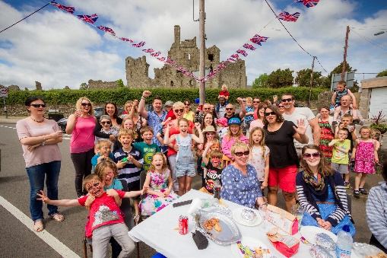
[insert council] is delighted to share that the Eden Project are bringing this years’ Big Lunch to the May bank holiday weekend (6 – 8 May) in celebration of the Coronation and neighbourhoods across [region] are invited to share food and fun together in a nationwide act of community and friendship.

Tens of thousands of events are expected to take place across the United Kingdom, bringing neighbours, communities and the nation together, and raising community spirits as part of this historic occasion.

A momentous weekend is planned, with the Coronation Big Lunch set to be one of the highlights – and now [Council name] is inviting you to join the celebrations or to hold a Big Lunch anytime in June – during the associated ‘Month of Community’.

The Big Lunch is an idea from the Eden Project made possible by The National Lottery, that brings millions of people together annually in June, boosting community spirit, reducing loneliness and supporting charities and good causes, with £22m raised last year. Whether it’s a full-blown street party, a picnic or a small gathering over a cup of tea and something to eat, the idea is simply to meet and have fun together over food.

Last summer 1 in 4 (17.2m) people across all four nations got together with a Big Lunch, with many positive
impacts felt by those taking part. More than 11 million people said that it helped them to feel less lonely, 92% of organisers reported it had a positive impact on their community, and almost two thirds of people who took part said it encouraged people to get more involved in voluntary work.

With so many benefits, Eden Project Communities, the people behind The Big Lunch, hope that every cup of tea shared with a neighbour and street party held will help to raise community spirits, as people everywhere are invited to get to know their community a little better.

That’s why [council name] has taken special steps to support residents by: [add or delete as appropriate]

- Waiving street closure fees for any Coronation Big Lunch events in 2023
- Waiving street closure fees for any Big Lunch events held in June 2023
- Making road closure applications easier than ever [find out more here - link]
- Offering up a limited number of Coronation Big Lunch funding grants [find out more here - link]

With Big Lunches set to take place across the country, why not pick a date to get involved and spread the word so that [area] has the biggest celebration ever!

To find out more and get your free Big Lunch Pack, visit www.coronationbiglunch.com

ENDS

Editors notes:

About Eden Project Communities and The Big Lunch
We aim to improve the happiness and wellbeing of people across the UK by bringing communities together and inspiring them to make positive changes where they live. As part of the Eden Project, we're exploring how people can work with each other, and with nature, towards a better future. We believe that connected communities are more resilient against local and global issues and are better equipped to tackle challenges and bring about positive change.

The Big Lunch is the UK’s annual big date to celebrate and give thanks to our neighbours and communities. We bring neighbours and communities together to share food, friendship and fun and raise money for local causes, throughout June each year. It’s an idea from the Eden Project made possible by The National Lottery and is supported by PG tips, Iceland and The Food Warehouse, the Pears Foundation and The Julia and Hans Rausing Trust.

Find out more at www.edenprojectcommunities.com

About The National Lottery
The National Lottery is the largest community funder in the UK and proud to award money raised by National
Lottery players to communities across England, Scotland, Wales and Northern Ireland. National Lottery players
raise £30 million each week for good causes throughout the UK. Since June 2004, they have made over 200,000
grants and awarded over £9 billion to projects that have benefited millions of people.

About [Council]

